**Project Title: AI-Powered Product Image Generator for Print on Demand**

**Brief Description:** Designed and implemented an AI-driven Product Image Generator that revolutionizes merchandising by creating stunning, tailored imagery for merchandise. This bot leverages AI image generation technologies to produce high-quality visuals that can be automatically published to online stores. The solution simplifies the process of creating and updating product images, ensuring that businesses can maintain a fresh and appealing online presence with minimal effort.

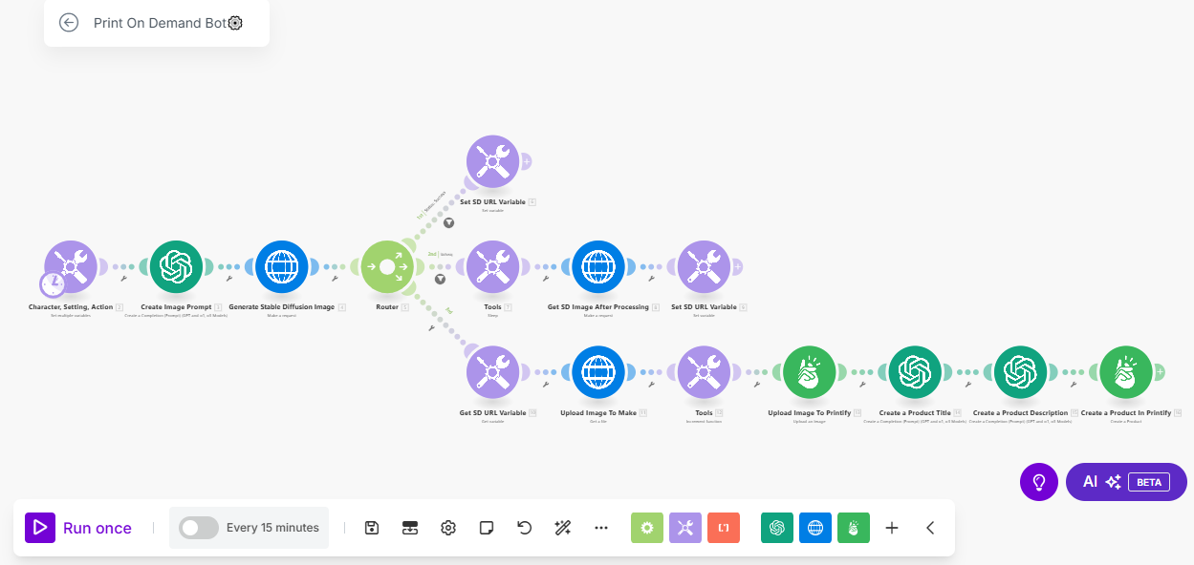

**Skills Used:** AI image generation, automation, e-commerce integration, and workflow optimization using Make.com. The bot integrates advanced AI technologies to generate visually appealing product images and automates the publication process to online stores.

**Outcomes:** Successfully developed a zero-coding, plug-and-play solution that runs on autopilot, making it accessible for users without technical expertise. The bot's ability to generate and publish images seamlessly ensures that online stores can consistently offer unique and engaging merchandise visuals. This project has enabled businesses to enhance their merchandising strategies, leading to increased customer engagement and sales. The fully customizable nature of the bot allows users to tailor image generation to specific product requirements, ensuring brand consistency and relevance.

**Key Features**:

* Automated generation of high-quality product images using AI.
* Seamless integration with online stores for automatic publication.
* Fully customizable and adjustable to meet specific merchandising needs.
* Zero coding required, ensuring ease of use for non-technical users.

This project demonstrates the effective use of AI and automation to enhance e-commerce merchandising, providing businesses with a powerful tool to create and manage compelling product imagery effortlessly